What is a Research Paper?

"Research paper". What image comes into mind as you hear those words: working with stacks of articles and books, hunting the "treasure" of others' thoughts? Whatever image you create, it's a sure bet that you're envisioning sources of information--articles, books, websites, etc. Yet a research paper is more than the sum of your sources, more than a collection of different pieces of information about a topic, and more than a review of the literature in a field. A research paper analyzes a perspective or argues a point. Regardless of the type of research paper you are writing, your finished research paper should present your own thinking backed up by others' ideas and information.
To draw a parallel, a lawyer researches and reads about many cases and uses them to support their own case. A scientist reads many case studies to support an idea about a scientific principle. In the same way, a history student writing about the Vietnam War might read newspaper articles and books and interview veterans to develop and/or confirm a viewpoint and support it with evidence.
A research paper is an expanded essay that presents your own interpretation or evaluation or argument. When you write an essay, you use everything that you personally know and have thought about a subject. When you write a research paper you build upon what you know about the subject and make a deliberate attempt to find out what experts know. A research paper involves surveying a field of knowledge in order to find the best possible information in that field. And that survey can be orderly and focused, if you know how to approach it.
* http://www.esc.edu/online-writing-center/resources/research/research-paper/

There are other benefits as well. Writing the research paper is an exercise in logic, imagination, and common sense. As you chip away at the mass of data and information available on your chosen topic, you learn
- How to track down information
- How to organize
- How to use the Internet in your research
- How to discriminate between useless and useful opinions
- How to summarize
- How to budget your time
- How to conceive of and manage a research project from start to finish

**Anthony C. Winkler and Jo Ray Metherell, Writing the Research Paper: A Handbook, 8th ed. Wadsworth Publishing, 2011)

Evaluating Sources
Evaluating sources is an important skill. It's been called an art as well as work—much of which is detective work. You have to decide where to look, what clues to search for, and what to accept. You may be overwhelmed with too much information or too little. The temptation is to accept whatever you find. But don't be tempted. Learning how to evaluate effectively is a skill you need both for your course papers and for your life.
When writing research papers, you will also be evaluating sources as you search for information. You will need to make decisions about what to search for, where to look, and once you've found material on your topic, if it is a valid or useful source for your writing.

Where do I begin?
We live in an age overflowing with sources of information. With so many information sources at our fingertips, knowing where to start, sorting through it all and finding what we want can be overwhelming! This handout provides answers to the following research-related questions: Where do I begin? Where should I look for information? What types of sources are available?
Before you begin your research, you should ask yourself some questions. These will help narrow your search parameters.

What kind of information are you looking for?
Do you want facts? Opinions? News reports? Research studies? Analyses? Personal reflections? History?

Where would be a likely place to look?
Which sources are likely to be most useful to you? Libraries? The Internet? Academic periodicals? Newspapers? Government records?

If, for example, you are searching for information on some current event, a reliable newspaper like the New York Times will be a useful source. Are you searching for statistics on some aspect of the U.S. population? Then, start with documents such as United States census reports. Do you want some scholarly interpretations of literature? If so, academic periodicals and books are likely to have what you’re looking for. Want to know about commercial products? Will those companies have Web sites with information? Are you searching for local history? Then a county library, government office, or local newspaper archive is likely to be the most useful.

Types of Research
Online vs. Print Publications
An important distinction when doing research is the difference between traditional publications and Internet resources. The Internet may be the most convenient place to begin your research, but it is not always the best.

Internet Sources: Anything published exclusively online in a variety of digital formats. Material includes: web pages, PDF documents, ebooks, multimedia.
Traditional Publications: This includes anything that has been published in print form and is widely available at libraries and bookstores. Material includes: books, textbooks, newspapers, popular and scholarly journals, and magazines.
With the advent of new technologies, many traditional resources are now available online (including newspaper articles, magazines, book chapters, and journal articles). Pay careful attention to whether the source you have found is an online-only source or if it has a print component as well.

RESEARCH PAPER STEP 1: Writing a Statement of Purpose
What is it? A Statement of Purpose is a sentence that you write, which states, in some detail, what you want to learn about in your research project. The statement guides you as you work so that you will read and take notes only on what's needed for your project.
Writing a statement of purpose will do 4 things to help you:
- You will get more interested in your project.
- It will keep you from getting overwhelmed and panicky at all the information you may find.
- It will help you develop a Claim Statement, which comes later on in the research process.
- It saves you valuable time and effort.
When and How to do it? After you focus your topic, after some overview reading, write a sentence that says what you want to learn about. Don't worry if you're not totally sure, your Statement of Purpose may change 3 or 4 times before you're done. To write the sentence, first answer these questions for yourself as best as you can:
1. What is my real personal interest in the topic? (There will always be something that can interest you)
2. What do I specifically want to learn about my topic? (Don't overwhelm yourself with too many things. Two or three are plenty.)
Start your Statement of Purpose with words like "I want to learn about..."

RESEARCH PAPER STEP 2: Making Source Cards
What are they? They are index cards on which you put all of the information you will need about all the sources used.
They will help you to:
- Identify the sources of quotations and ideas for citing your sources later.
- Find sources again if you need them.
- Make your Works Cited page

How to do it? Use index cards to make your source cards; use only one card per source. Code each source its own number, starting with the number 1. You will later link your notes to these code numbers.
Sample Source Cards: Below are examples of a source card for an internet web page and a book.
AUTHOR SOURCE #

ARTICLE TITLE

SOURCE
NAME

URL (address)
OF SITE

LOCATION OF
SOURCE FOR A
WEBSITE
Wood, Michael #1

“The Shakespeare Paper Trail: The Early Years”

BBC.com

http://www.bbc.co.uk/history/british/tudors/shakespeare_early_01.shtml
Website

AUTHOR SOURCE #

BOOK TITLE COPYRIGHT
DATE
PLACE OF
PUBLICATION

LOCATION OF
SOURCE FOR A BOOK

Brown, Samuel #2

Money is the Nature of the Game

Chicago: Bullet Publishers, 1998.

BVT Library

RESEARCH PAPER STEP 3: Making Note Cards
Why do it? It is useful to take notes on index cards because it gives you the flexibility to change the order of your notes and group them together easily.
How do I do it?
1. Write the subtopic heading of the note at the top of each note card.
2. Include the source's number on the card
3. Write only one main point on a note card
4. Only write information directly related to your Statement of Purpose.
5. Be accurate: double check direct quotes and statistics.
6. Identify direct quotes with quotation marks and the person's name.
7. Bracket your own words [ ] when you add them into a quote.
8. Use ellipsis points [...] where you leave out non-essential words from a quote.
9. Write the page number of the source after the note.
Sample note card:
SUBTOPIC SOURCE #
HEADING

NOTE

PAGE
REFERENCE
Shakespeare’s Early Life #1
_______________________________________________________________
“Shakespeare was born in Stratford upon Avon in 1564, only five years or so into the reign of Elizabeth I. The local church has a record of his baptism on 26 April, so he was a born maybe three or four days earlier.”

Page 2

RESEARCH PAPER STEP 4: Writing a Claim Statement
What is it? A claim statement is a strong statement that you can prove with evidence. It is not a simple statement of fact. A claim statement should be the product of your own critical thinking after you have done some research. Your claim statement will be the main idea of your entire project. It can also be thought of as the angle or point of view from which you present your material.

When do I write it? You will develop a claim statement about your research topic after you have written a Statement of Purpose and done some actual research into the topic. You will then present your claim statement in your introduction, prove it with evidence in the body of your paper, project, or presentation, and finally restate it along with a summary of your evidence in your conclusion.

How do I write it?
- Look again at your Statement of Purpose
- Look at the kinds of information you have been finding while taking notes.
- Decide what kind of statement you have enough evidence to prove.
(Be sure that you have done enough research to make a strong argument. You may be challenged.)
- Write that as your claim statement.
There are many ways to approach writing a claim statement. Here are some ways to approach it:
- Define a problem and state your opinion about it
- Discuss the current state of an issue or problem and predict how it might resolve
- Put forth a possible solution to a problem
- Look at an issue/topic from a new, interesting perspective
- Theorize how the world might be different today if something had/had not happened in the past
- Compare two or more of something similar and give your rating about them (cars, authors, computers, colleges, books)
- Put out your ideas about how something was influenced to be the way it is or was (music, art, political leadership, genocide)

Example of turning a Statement of Purposes into a claim Statement
STATEMENT OF PURPOSE | POSSIBLE CLAIM STATEMENT
"I want to know why Christians and Muslims fought so hard with each other during the middle ages." | Even though Christians and Muslims were supposedly fighting for religious dominance in the medieval world, their motives were strongly affected by the desire for land and economic power.  or  Medieval Christians and Muslims were fighting exclusively for deeply held religious beliefs.

RESEARCH PAPER STEP 5: Making an Outline
What is it? An outline is an abbreviated picture of the parts of your paper or project and the order in which they will come. You can think of it as a "road map" of your journey toward making a final product.
It helps you to...
- Stay on course and not get off-track when you put your final product together.
- See if you have enough (or too much) material to support your claim statement.
- Figure out the order in which your subtopics will appear in your final product.

How to do it?
Start with an introduction and end with a conclusion. Figure out the most logical flow of information, the best order for the information to be in, using the subtopics created earlier on the note cards. Put your subtopics with the key points that support them, in words or short phrases, into a list or diagram that shows how they will flow from beginning to end. You can put your note cards in this order now. There is always more than one way to do this, so figure out what you like best. There are many different types of outline diagrams. Use this model for a formal outline which is the type that most teachers expect to see if they ask for one.
Outline Format
I. Introduction
A. Background
B. Claim Statement
II. (First Point / Controlling Idea)
A. (First Supporting Evidence)
B. (Second Supporting Evidence)
III. (Second Point / Controlling Idea)
A. (First Supporting Evidence)
B. (Second Supporting Evidence)
III. (Third Point / Controlling Idea)
A. (First Supporting Evidence)
B. (Second Supporting Evidence)
IV. (Fourth Point / Controlling Idea)
A. (First Supporting Evidence)
B. (Second Supporting Evidence)
V. (Fifth Point / Controlling Idea)
A. (First Supporting Evidence)
B. (Second Supporting Evidence)
VI. (Sixth Point / Controlling Idea)
A. (First Supporting Evidence)
B. (Second Supporting Evidence)
VII. Conclusion: A restatement of the main points of your paper.

RESEARCH PAPER STEP 6: Writing the Introduction
What is it? An introduction is the first paragraph of a written research paper, or the first thing you say in an oral presentation, or the first thing people see, hear, or experience about your project. It has two parts:
1. A general introduction to the topic you will be discussing
2. Your claim statement

When do I do it?
Many books recommend writing your introduction last, after you finish your project. This is to make sure that you introduce what you are actually going to say. If your project changes in the creating process, it is important to make sure that your introduction accurately reflects what you will be saying.
If, however, you have written a good outline and stick to it, then it is fine to start writing your introduction first. Just make sure in your proofreading that you have kept the thread consistent throughout the paper.
How do I do it? Start with a couple of sentences that introduce your topic to your reader. You do not have to give too much detailed information; save that for the body of your paper. Make these sentences as interesting as you can. Through them, you can hook a reader and get them very interested in the line of thinking you are going to develop in your project. Then state your claim. The length of your introduction depends on the length and complexity of your project.
Example Introduction generated from original Statement of Purpose (The BOLD text is the claim statement.)
Throughout the history, differences in religious beliefs have led to numerous conflicts around the globe. During the Middle Ages in Europe and the Middle East there was much armed conflict between Christians and Muslims. Christians called these conflicts the Crusades because they were fighting under the sign of the cross to save the holy lands of the Bible from being desecrated by non-Christians. However, the true reason for fighting for these lands was mainly a desire for economic gain that prompted the Christian leaders to send soldiers to fight in the Holy Land.

RESEARCH PAPER STEP 7: Writing the Body of the Paper
How do I begin to write the body of a research paper?
- Take out your outline and your note cards.
- Before you begin writing, take some time to put all of your note cards and borrowed material (pictures, etc.) in the order they will appear in your project. You can use your outline as a guide for this important step. You don't want to be searching for these things as you are writing.
- You will write your first paragraph about the first subtopic in your outline. (Your introduction will be written later.) Introduce that subtopic in the first sentence.
- The body of that paragraph will be more information about the first subtopic and your evidence for why it supports your claim statement.
- Use your note cards to get borrowed material (quotes, statistics, etc) to use as evidence. You may also include pictures here from other sources. Remember that you need to cite all borrowed material immediately after you use it.
- You will continue in this manner until you reach the conclusion section of your outline.

Once you are done, do a first proof read to check for spelling and grammatical errors, and make sure that all borrowed material is properly cited.

RESEARCH PAPER STEP 8: Writing a Conclusion
What is it? A conclusion is the last paragraph in your research paper, or the last part in any other type of presentation.

Why do it? A conclusion is like the final chord in a song. It makes the listener feel that the piece is complete and well done. The same is true for your audience. You want them to feel that you supported what you stated in your claim. You then become a reliable author for them and they are impressed by that and will be more likely to read your work in the future. They may also have learned something and maybe have had their opinion changed by what you have written or created!

How do I do it? A conclusion is, in some ways, like your introduction. You restate your claim and summarize your main points of evidence for the reader. You can usually do this in one paragraph.

RESEARCH PAPER STEP 9: Compile a Works Cited page
What is it? A Works Cited is an alphabetical list of the sources (also called "works") you used in the body of your project.
Where does it go? It should be the last page in your project.
*** Complied from the http://www.crlsresearchguide.org , created by Holly Samuels, Librarian: Cambridge Rindge and Latin School Cambridge, MA USA

RESEARCH PAPER STEP 10: Formatting the First Page of Your Paper
- Do not make a title page for your paper unless specifically requested.
- In the upper left-hand corner of the first page, list your name, your instructor's name, the course, and the date. Again, be sure to use double-spaced text.
- Double space again and center the title. Do not underline, italicize, or place your title in quotation marks; write the title in Title Case (standard capitalization), not in all capital letters.
- Use quotation marks and/or italics when referring to other works in your title, just as you would in your text: Fear and Loathing in Las Vegas as Morality Play; Human Weariness in "After Apple Picking"
- Double space between the title and the first line of the text.
- Create a header in the upper right-hand corner that includes your last name, followed by a space with a page number; number all pages consecutively with Arabic numerals (1, 2, 3, 4, etc.), one-half inch from the top and flush with the right margin. (Note: Your instructor or other readers may ask that you omit last name/page number header on your first page. Always follow instructor guidelines.)
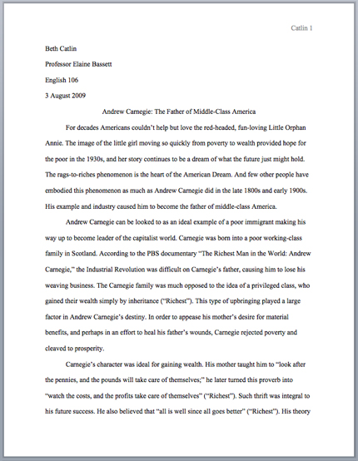
- The First Page of an MLA Paper
General MLA Guidelines
- Type your paper on a computer and print it out on standard, white 8.5 x 11-inch paper.
- Double-space the text of your paper, and use Times New Roman, font size 12 pt.
- Leave only one space after periods or other punctuation marks (unless otherwise instructed by your instructor).
- Set the margins of your document to 1 inch on all sides.
- Indent the first line of paragraphs one half-inch from the left margin. MLA recommends that you use the Tab key as opposed to pushing the Space Bar five times.
- Create a header that numbers all pages consecutively in the upper right-hand corner, one-half inch from the top and flush with the right margin. (Note: Your instructor may ask that you omit the number on your first page. Always follow your instructor's guidelines.)
- Use italics throughout your essay for the titles of longer works and, only when absolutely necessary, providing emphasis.
- If you have any endnotes, include them on a separate page before your Works Cited page. Entitle the section Notes (centered, unformatted).

RESEARCH PROJECT FINAL PRODUCT

Goal / Prompt: Choose one of the literary periods studied in class and one significant author from that age to identify the political, social, and religious ideals of that period and to show how the career and works of the author reflect those beliefs in a well-developed research paper. Include brief biographical information about the author while meeting the following FCA’s.

FCA’s:
FCA #1: Synthesize at least five (5) sources and cite at least twelve (12) pieces of textual evidence (min. 2 per controlling idea) that work to establish the relationship identified in the claim according to MLA (50 pts)
FCA #2: Demonstrate a relationship between a literary period and the work of an author historically, politically, and socially (20 pts)
FCA #3: Compose a well-written introductory paragraph with a clearly stated debatable claim statement (15 pts)
FCA #4: Compose a well-developed research paper using MLA guidelines and Standard English conventions (15 pts)
Format (Based on the MLA Handbook for Writers of Research Papers)
Your paper should be a minimum of six to eight pages (Not including the Works Cited page) and follow all MLA guidelines.

Paper: Use white, 81/2- by 11-inch paper.

Spacing: The entire paper should be doubled-spaced, including the heading, title, and Works Cited page.

Margins: Except for page numbers (see below), leave one-inch margins all around the text of your paper -- left side, right side, and top and bottom. (If you don’t change the margins, Microsoft Word is set to the correct margin width.) Paragraphs should be indented half an inch; Block quotations should be indented one (1) inch from the left margin.

Header with Page Numbers: A header with page numbers is required on every page, except on page one of your paper.
- Create a header that uses consecutive page numbers and your last name in the right-hand top corner of your paper.
- Ensure this header appears on every page, including an endnotes or Works Cited page.

Adding the Page Header in MS-Word (Windows)
- Insert -> Page Number -> Top of Page -> (choose the right-justified “Plain Number” option)
- The cursor will jump automatically to the right place for you to type your last name followed by a space.
- Click anywhere in the body of the paper to exit the header area.

Heading and Title:
Your research paper does not need a title page. At the top of the first page, at the left-hand margin, type your name, your instructor's name (Mr. Kehowski), the course name (Honors English III), and the date -- all on separate, double-spaced lines. Then double-space again and center the title above your text. (If your title requires more than one line, double-space between the lines.) Double-space again before beginning your text. The title should be neither underlined nor written in all capital letters. Capitalize only the first, last, and principal words of the title. Titles might end with a question mark or an exclamation mark if that is appropriate, but not in a period. Titles written in other languages are capitalized and punctuated according to different rules, and writers should consult the MLA Guide.

Works Cited Page
•Begin your Works Cited page on a separate page at the end of your research paper. It should have the same one-inch margins and last name, page number header as the rest of your paper.
•Label the page Works Cited (do not italicize the words Works Cited or put them in quotation marks) and center the words Works Cited at the top of the page.
•Double space all citations, but do not skip spaces between entries.
•Indent the second and subsequent lines of citations by 0.5 inches to create a hanging indent.

*Block quotes are required with longer quotations, "more than four lines in your paper." Block quotes are continuously indented from the left margin one inch Double space within, before, and after a block quote, as with the rest of the text. Do not place the quote inside quotation marks. The parenthetical citation appears after the period. (see ex. Below)

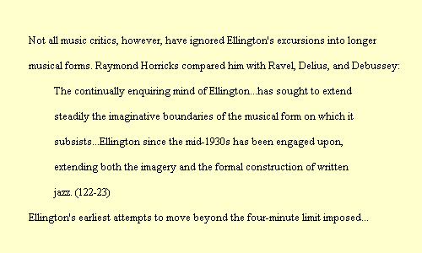
^ Don’t indent the next sentence of analysis
Indent Block Quote one inch >>>>>>>>

The opening page to your essay should use the format shown below:
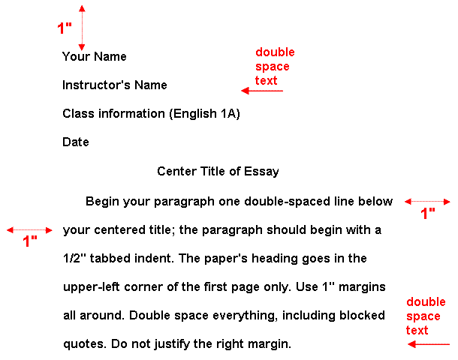

The Works Cited page to your essay should use the format shown below:
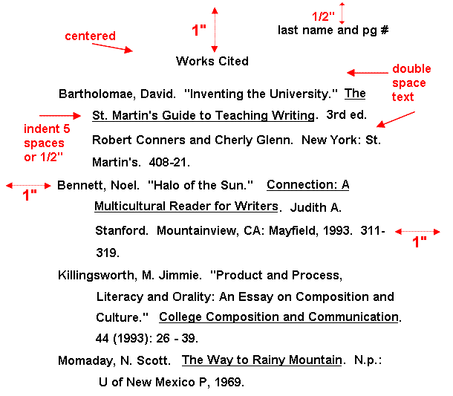

ASSIGNMENT DEADLINE CHECKLIST
ASSIGNMENT | DATE DUE
STEP 1: Writing a Statement of Purpose
STEP 2: Making Source Cards
STEP 3A: Making Note Cards (24-30 direct quotes / min. of 4 for each Controlling Idea)
STEP 3B: Making Note Cards (provide analysis on back of each Note Card)
STEP 4: Writing a Claim Statement
STEP 5: Making an Outline
STEP 6: Final Product Due Date

American Literary Periods to Select From
Early American Literature
Period Dates, Name, Key Hist. Events | Period Characteristics | Significant Authors
1600-1750  Puritanism  >First “American” colonies established  >Salem Witch Trials | 1. Wrote mostly diaries and histories, which expressed the connections between God and their everyday lives.  2. Sought to “purify” the Church of England by reforming to the simpler forms of worship and church organization described in the New Testament  3. Saw religion as a personal, inner experience.  4. Believed in original sin and “elect” who would be saved.  5. Used a plain style of writing | Edward Taylor  Anne Bradstreet  Jonathan Edwards

Early National Literature
Period Dates, Name, Key Hist. Events | Period Characteristics | Significant Authors
1750-1800  Rationalism  >Revolutionary War  >The Constitution  >The Bill of Rights  >The Declaration of Independence | 1. Mostly comprised of philosophers, scientists, writing speeches and pamphlets.  2. Human beings can arrive at truth (God’s rules) by using deductive reasoning, rather than relying on the authority of the past, on religious faith, or intuition. | Benjamin Franklin  Thomas Jefferson  Thomas Paine  Patrick Henry  Phillis Wheatley

The Romantic Period
Period Dates, Name, Key Hist. Events | Period Characteristics | Significant Authors
1800-1870  Romanticism  >Industrialization  >War of 1812  >California Gold Rush  >Abolitionist, Utopian, and Women’s Suffrage Movements | 1. Valued feeling, intuition, idealism, and inductive reasoning.  2. Placed faith in inner experience and the power of the imagination.  3. Shunned the artificiality of civilization and seek unspoiled nature as a path to spirituality.  4. Championed individual freedom and the worth of the individual.  5. Saw poetry as the highest expression of the imagination. | Benjamin Franklin  Thomas Jefferson  Thomas Paine  Patrick Henry  Phillis Wheatley
(The Two Schools)  A. Transcendentalism | 1. Human senses are limited; they convey knowledge of the physical world  2. Deeper truths can be grasped only through intuition  3. Observations of nature illuminate the nature of human beings  4. God, Nature, and Humanity are united in a shared universal soul | Ralph Waldo Emerson  Henry David Thoreau  Louisa May Alcott
B. Gothic (Dark Romantic) | 1. Use of haunting, eerie settings and strange, chilling events  2. Interest in intuition, imagination, and hidden truths  3. Reaction against the optimism of the Transcendentalists  4. Exploration of evil and the irrational depths of the human mind | Herman Melville  Edgar Allan Poe  Nathaniel Hawthorne  Emily Dickinson

The Age of Realism
Period Dates, Name, Key Hist. Events | Period Characteristics | Significant Authors
1850-1914  Realism  >The Civil War  >Reconstruction  >The Gilded Age | 1. Reaction against Romanticism  2. Common subjects; slums of rapidly growing cities, the representation of middle-class life, poor factory working conditions, and an interest in the scientific method  3. Represented the manner and environment of everyday life and ordinary people as realistically as possible (regionalism)  4. Sought to explain human behavior (psychologically/socially). | Mark Twain  Bret Harte  Kate Chopin  Ambrose Bierce  Jack London (Naturalism)

The Modern Age
Period Dates, Name, Key Hist. Events | Period Characteristics | Significant Authors
1914-1941  Modernism  >WWI  >Prohibition  >Women gain the right to vote  >The Great Depression | 1. A sense of disillusionment and a loss of faith in the American dream marked by falling farm prices, labor unrest, and radical politics  2. Emphasis on capturing reality, bold experimentation in style and form reflecting the fragmentation of society  3. Interest in the individual and the inner workings of the human mind | Ernest Hemingway  F. Scott Fitzgerald  William Faulkner  John Steinbeck  Katherine Anne Porter  Robert Frost  Gertrude Stein  Langston Hughes (Harlem Renaissance)  Zora Neale Hurston (Harlem Renaissance)

NAME:
DATE:
CLASS:

RESEARCH PAPER STEP 1: Writing a Statement of Purpose
Goal / Prompt: Choose one of the literary periods studied in class and one significant author from that time to identify the political, social, and religious ideals of that period and show how the career and works of the author reflect those beliefs in a well-developed research paper. Include brief biographical information about the author while meeting the following FCA’s.

First, answer these questions for yourself as best as you can. Type your responses in the boxes below.
1. What is my real personal interest in the topic? (There will always be something that can interest you)

2. What do I specifically want to learn about my topic? (Don't overwhelm yourself with too many things. Two or three are plenty.)

My Statement of Purpose (Start your Statement of Purpose with words like "I want to learn about...")

NAME:
DATE:
CLASS:

RESEARCH PAPER STEPS 4 & 5: Writing a Claim Statement/ Making an Outline
DIRECTIONS: Type your claim statement in the text box located on the outline. Then complete the remainder of the outline using the subtopic headings from the note cards.

I. Introduction
A. Background
B. Claim Statement
CLAIM STATEMENT:-

II.
1ST Point / Controlling Idea

A.
EV. #1-

B.
EV. #2-

III.
2nd Point / Controlling Idea

A.
EV. #1-

B.
EV. #2-

IV.
3rd Point / Controlling Idea

A.
EV. #1-

B.
EV. #2-

V.
4th Point / Controlling Idea

A.
EV. #1-

B.
EV. #2-

VI.
5th Point / Controlling Idea

A.
EV. #1-

B.
EV. #2-

VII.
6th Point / Controlling Idea

A.
EV. #1-

B.
EV. #2-

VII. Conclusion

Notes

