RESEARCH PROJECT FINAL PRODUCT

Goal / Prompt: Choose one of the literary periods studied in class and one significant author from that age to identify the political, social, and religious ideals of that period and to show how the career and works of the author reflect those beliefs in a well-developed research paper. Include brief biographical information about the author while meeting the following FCA’s.

FCA’s:
FCA #1: Synthesize at least five (5) sources and cite at least twelve (12) pieces of textual evidence (min. 2 per controlling idea) that work to establish the relationship identified in the claim according to MLA (50 pts)
FCA #2: Demonstrate a relationship between a literary period and the work of an author historically, politically, and socially (20 pts)
FCA #3: Compose a well-written introductory paragraph with a clearly stated debatable claim statement (15 pts)
FCA #4: Compose a well-developed research paper using MLA guidelines and Standard English conventions (15 pts)
Format (Based on the MLA Handbook for Writers of Research Papers)
Your paper should be a minimum of six to eight pages (Not including the Works Cited page) and follow all MLA guidelines.

Paper: Use white, 81/2- by 11-inch paper.

Spacing: The entire paper should be doubled-spaced, including the heading, title, and Works Cited page.

Margins: Except for page numbers (see below), leave one-inch margins all around the text of your paper -- left side, right side, and top and bottom. (If you don’t change the margins, Microsoft Word is set to the correct margin width.) Paragraphs should be indented half an inch; Block quotations should be indented one (1) inch from the left margin.

Header with Page Numbers: A header with page numbers is required on every page, except on page one of your paper.
- Create a header that uses consecutive page numbers and your last name in the right-hand top corner of your paper.
- Ensure this header appears on every page, including an endnotes or Works Cited page.

Adding the Page Header in MS-Word (Windows)
- Insert -> Page Number -> Top of Page -> (choose the right-justified “Plain Number” option)
- The cursor will jump automatically to the right place for you to type your last name followed by a space.
- Click anywhere in the body of the paper to exit the header area.

Heading and Title:
Your research paper does not need a title page. At the top of the first page, at the left-hand margin, type your name, your instructor's name (Mr. Kehowski), the course name (Honors English III), and the date -- all on separate, double-spaced lines. Then double-space again and center the title above your text. (If your title requires more than one line, double-space between the lines.) Double-space again before beginning your text. The title should be neither underlined nor written in all capital letters. Capitalize only the first, last, and principal words of the title. Titles might end with a question mark or an exclamation mark if that is appropriate, but not in a period. Titles written in other languages are capitalized and punctuated according to different rules, and writers should consult the MLA Guide.

Works Cited Page
•Begin your Works Cited page on a separate page at the end of your research paper. It should have the same one-inch margins and last name, page number header as the rest of your paper.
•Label the page Works Cited (do not italicize the words Works Cited or put them in quotation marks) and center the words Works Cited at the top of the page.
•Double space all citations, but do not skip spaces between entries.
•Indent the second and subsequent lines of citations by 0.5 inches to create a hanging indent.

*Block quotes are required with longer quotations, "more than four lines in your paper." Block quotes are continuously indented from the left margin one inch Double space within, before, and after a block quote, as with the rest of the text. Do not place the quote inside quotation marks. The parenthetical citation appears after the period. (see ex. Below)

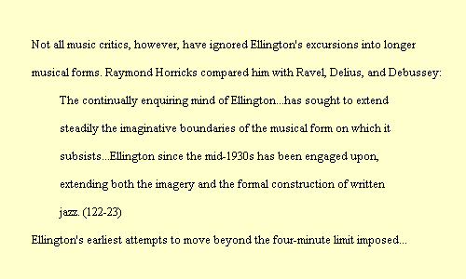
^ Don’t indent the next sentence of analysis
Indent Block Quote one inch >>>>>>>>

The opening page to your essay should use the format shown below:
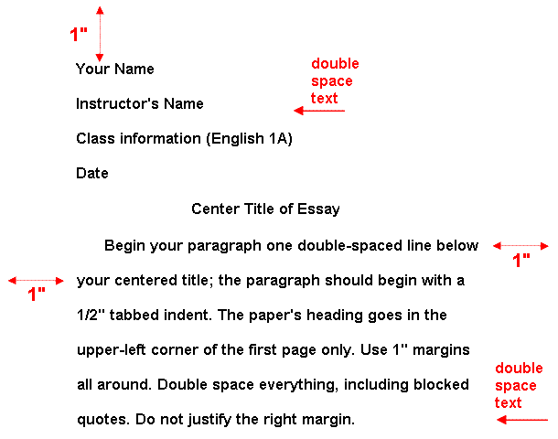

The Works Cited page to your essay should use the format shown below:
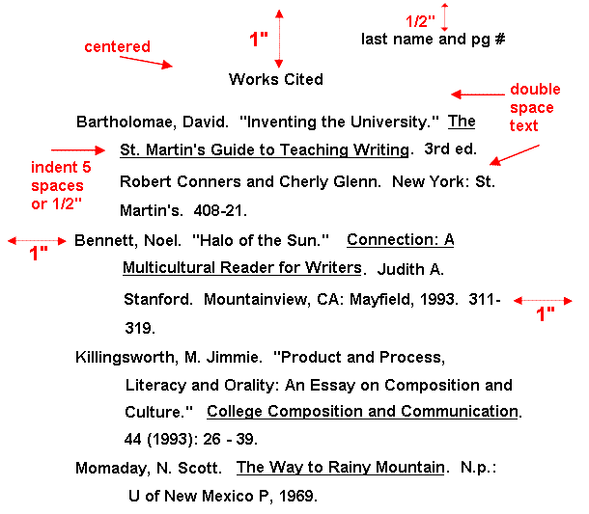

ASSIGNMENT DEADLINE CHECKLIST
ASSIGNMENT | DATE DUE
STEP 1: Writing a Statement of Purpose
STEP 2: Making Source Cards
STEP 3A: Making Note Cards (24-30 direct quotes / min. of 4 for each Controlling Idea)
STEP 3B: Making Note Cards (provide analysis on back of each Note Card)
STEP 4: Writing a Claim Statement
STEP 5: Making an Outline
STEP 6: Final Product Due Date

American Literary Periods to Select From
Early American Literature
Period Dates, Name, Key Hist. Events | Period Characteristics | Significant Authors
1600-1750  Puritanism  >First “American” colonies established  >Salem Witch Trials | 1. Wrote mostly diaries and histories, which expressed the connections between God and their everyday lives.  2. Sought to “purify” the Church of England by reforming to the simpler forms of worship and church organization described in the New Testament  3. Saw religion as a personal, inner experience.  4. Believed in original sin and “elect” who would be saved.  5. Used a plain style of writing | Edward Taylor  Anne Bradstreet  Jonathan Edwards

Early National Literature
Period Dates, Name, Key Hist. Events | Period Characteristics | Significant Authors
1750-1800  Rationalism  >Revolutionary War  >The Constitution  >The Bill of Rights  >The Declaration of Independence | 1. Mostly comprised of philosophers, scientists, writing speeches and pamphlets.  2. Human beings can arrive at truth (God’s rules) by using deductive reasoning, rather than relying on the authority of the past, on religious faith, or intuition. | Benjamin Franklin  Thomas Jefferson  Thomas Paine  Patrick Henry  Phillis Wheatley

The Romantic Period
Period Dates, Name, Key Hist. Events | Period Characteristics | Significant Authors
1800-1870  Romanticism  >Industrialization  >War of 1812  >California Gold Rush  >Abolitionist, Utopian, and Women’s Suffrage Movements | 1. Valued feeling, intuition, idealism, and inductive reasoning.  2. Placed faith in inner experience and the power of the imagination.  3. Shunned the artificiality of civilization and seek unspoiled nature as a path to spirituality.  4. Championed individual freedom and the worth of the individual.  5. Saw poetry as the highest expression of the imagination. | Benjamin Franklin  Thomas Jefferson  Thomas Paine  Patrick Henry  Phillis Wheatley
(The Two Schools)  A. Transcendentalism | 1. Human senses are limited; they convey knowledge of the physical world  2. Deeper truths can be grasped only through intuition  3. Observations of nature illuminate the nature of human beings  4. God, Nature, and Humanity are united in a shared universal soul | Ralph Waldo Emerson  Henry David Thoreau  Louisa May Alcott
B. Gothic (Dark Romantic) | 1. Use of haunting, eerie settings and strange, chilling events  2. Interest in intuition, imagination, and hidden truths  3. Reaction against the optimism of the Transcendentalists  4. Exploration of evil and the irrational depths of the human mind | Herman Melville  Edgar Allan Poe  Nathaniel Hawthorne  Emily Dickinson

The Age of Realism
Period Dates, Name, Key Hist. Events | Period Characteristics | Significant Authors
1850-1914  Realism  >The Civil War  >Reconstruction  >The Gilded Age | 1. Reaction against Romanticism  2. Common subjects; slums of rapidly growing cities, the representation of middle-class life, poor factory working conditions, and an interest in the scientific method  3. Represented the manner and environment of everyday life and ordinary people as realistically as possible (regionalism)  4. Sought to explain human behavior (psychologically/socially). | Mark Twain  Bret Harte  Kate Chopin  Ambrose Bierce  Jack London (Naturalism)

The Modern Age
Period Dates, Name, Key Hist. Events | Period Characteristics | Significant Authors
1914-1941  Modernism  >WWI  >Prohibition  >Women gain the right to vote  >The Great Depression | 1. A sense of disillusionment and a loss of faith in the American dream marked by falling farm prices, labor unrest, and radical politics  2. Emphasis on capturing reality, bold experimentation in style and form reflecting the fragmentation of society  3. Interest in the individual and the inner workings of the human mind | Ernest Hemingway  F. Scott Fitzgerald  William Faulkner  John Steinbeck  Katherine Anne Porter  Robert Frost  Gertrude Stein  Langston Hughes (Harlem Renaissance)  Zora Neale Hurston (Harlem Renaissance)

NAME:
DATE:
CLASS:

RESEARCH PAPER STEP 1: Writing a Statement of Purpose
Goal / Prompt: Choose one of the literary periods studied in class and one significant author from that time to identify the political, social, and religious ideals of that period and show how the career and works of the author reflect those beliefs in a well-developed research paper. Include brief biographical information about the author while meeting the following FCA’s.

First, answer these questions for yourself as best as you can. Type your responses in the boxes below.
1. What is my real personal interest in the topic? (There will always be something that can interest you)

2. What do I specifically want to learn about my topic? (Don't overwhelm yourself with too many things. Two or three are plenty.)

My Statement of Purpose (Start your Statement of Purpose with words like "I want to learn about...")

NAME:
DATE:
CLASS:

RESEARCH PAPER STEPS 4 & 5: Writing a Claim Statement/ Making an Outline
DIRECTIONS: Type your claim statement in the text box located on the outline. Then complete the remainder of the outline using the subtopic headings from the note cards.

I. Introduction
A. Background
B. Claim Statement
CLAIM STATEMENT:-

II.
1ST Point / Controlling Idea

A.
EV. #1-

B.
EV. #2-

III.
2nd Point / Controlling Idea

A.
EV. #1-

B.
EV. #2-

IV.
3rd Point / Controlling Idea

A.
EV. #1-

B.
EV. #2-

V.
4th Point / Controlling Idea

A.
EV. #1-

B.
EV. #2-

VI.
5th Point / Controlling Idea

A.
EV. #1-

B.
EV. #2-

VII.
6th Point / Controlling Idea

A.
EV. #1-

B.
EV. #2-

VII. Conclusion

Notes

